URL: <http://www.kameda.com/us/index.html>

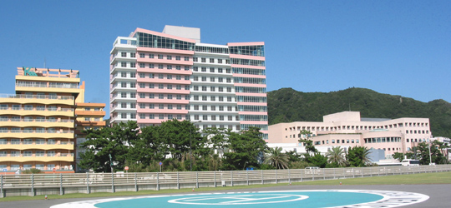

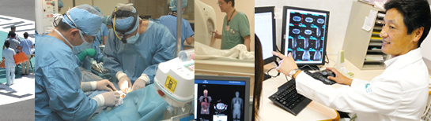

 

**Kameda's Mission**In order to contribute to the happiness and well being of everyone involved with the Kameda Medical Center, we endeavor to provide the highest level of medical service.

The Values of Kameda Medical Center  
We will

* Hold our patients in the highest esteem, with their needs being the highest priority of all.
* Instill trust and respect in all of our employees which in turn binds them closely together to serve our patients.
* Foster a high spirit that is not detracted by challenge or hindered by fixed needs.

**Services:**

**31 Departments**  
Internal Medicine, Infectious disease, Psychiatry, Neurology, Respiratory, Digestive Organs, Cardiovascular, Allergy, Rheumatology, Pediatrics, General Surgery, Orthopedics, Plastic Surgery, Cosmetic Surgery, Neurosurgery, Cardiac & Vascular Surgery, Pediatric Surgery, Dermatology, Urology, Obstetrics, Gynecology, Ophthalmology, Otolaryngology, Rehabilitation, Radiology, Anesthesiology, Dentistry, Orthodontics, Pediatric Dentistry, Oral Surgery, Oncology

The hospital has

• Number of beds  
19 beds

• Examination rooms  
Over 100

**Doctors credentials:**

**Doctors in General internal medicine**

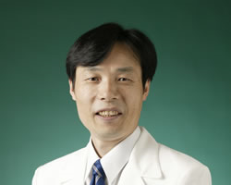

Chief of General Internal Medicine

Hiroshi NISHINO

Department name

General Internal Medicine

Language Spoken

English

Medical School

University of Tokushima School of Medicine

Education & Career

1978: Graduated from University of Tokushima, School of Medicine

1978-1986: First Department of Internal Medicine University of Tokushima Hospital

1986-1996: Mayo Clinic, Rochester, MN, USA

1996-2004: Neurology, Kameda Medical Center

2004-：General Internal Medicine, Kameda Medical Center

Subspeciality

Internal Medicine

Special Qualifications

Board Certified Physician of Japanese Society of Internal Medicine

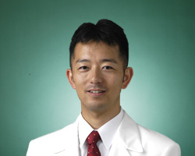

**Vice Chief of General Internal Medicine**

Makito YAEGASHI

Department name

General Internal Medicine

Language Spoken

English

Medical School

Hirosaki University School of Medicine

Education & Career

・Critical Care Medicine Fellow 2005-2006

University of Pittsburgh Medical Center, Pittsburgh, PA

・Pulmonary and Critical Care Medicine Fellow 2003 - 2005

State University of New York, Downstate Medical Center, Brooklyn, NY

・Resident, Internal Medicine, St. Luke’s-Roosevelt Hospital Center 2000 &#8211; 2003

Columbia University College of Physicians & Surgeons, New York, NY

・Senior Intern, U.S. Naval Hospital, Okinawa 1999 &#8211; 2000, Okinawa, Japan

・ Resident, Internal Medicine, Kameda Medical Center 1997 &#8211; 1999, Kamogawa, Japan

Subspeciality

Medicine, Pulmonary Medicine, and Critical Care Medicine

Special Qualifications

The American Board of Critical Care Medicine

The American Board of Pulmonary Medicine

The American Board of Internal Medicine, number

Board Certified Member of the Japanese Society of Internal Medicine

Japanese National Board Certified

**Doctors in cardiology**

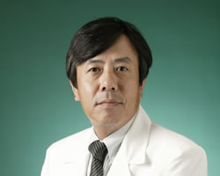

Director of Cardiology

Yuji HASHIMOTO

Department name

Cardiology

Language Spoken

English

Medical School

Niigata University, School of Medicine

Education & Career

1976: Graduated from Niigata University, School of Medicine

1976-78: Residency in Tokyo Medical and Dental University, School of Medicine

1978-80: Clinical fellow, Tokyo Medical and Dental University, School of Medicine

1980-81: Medical Staff in Division of Cardiology, Tokyo Metropolitan Hiroo Hospital

1982-85: Clinical fellow, Tokyo Medical and Dental University, School of Medicine

1985-89: Head Physician in Division of Cardiology, National Tachikawa Hospital

1989-96: Assistant Professor, Tokyo Medical and Dental University, School of Medicine

1993-94: Exchange visitor as research scholar, University of California, Irvine

1996-97: Lecturer, Tokyo Medical and Dental University, School of Medicine

1997-present: Chief of Department Cardiovascular Medicine, Kameda Medical Center

Subspeciality

Cardiology

Special Qualifications

Boad certificated member of the Japanese Society of Internal medicne

Boad advanced certificated physician of the Japanese Society of Internal medicne

Boad certificated member of the Japnese Circulation Society

Fellow of the Japanese College of Cardiology

Dr. of Medical Science (equivalent to Ph. D.). Tokyo Medical and Dental University, School of Medicine

Clinical Professor of Tokyo Medical and Dental University, School of Medicine

Clinical Instructor of Advanced Clinical Training of Foreign Medical Practitioners

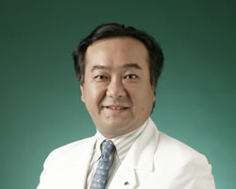

**Chief of Cardiology**

Akihiko MATSUMURA

Department name

Cardiology

Medical School

Tokyo Medical and Dental University

Education & Career

1987: Graduated from University of Tokyo Medical and Dental University

1992: Residency in Third department of internal medicine, Tokyo medical and dental unversity

1997: Department of cardiology, Kasai cardiology and neurosurgery hospital

1997-2008: Department of cardiology, Kameda Medical Center

Subspeciality

Catheter Intervention

Special Qualifications

Board Certified Pyshician of the Japanese society of internal medicine

Board Certified Specialist of the Japanese circulation society

Board Advanced Certified Specialist of Japanese society of interventional cardiology

**Doctors in endocrinology**

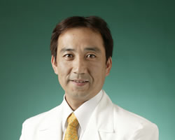

Vice Chief of Diabetes and Endocrinology

Masahiro MASUZAWA

Department name

Diabetes and Endocrinology

Medical School

Hamamatsu University School of Medicine

Education & Career

1992: Graduated from Hamamatsu University School of Medicine

1998: Endocrinology, Kameda Medical Center

2003 July: Assistant Chief of Diabetes and Endocrinology

Subspeciality

Internal Medicine, Endocrine Disease

Special Qualifications

Board Certified Physician of Japanese Society of Internal Medicine

Board Certified Specialist of Japanese Society of Internal Medicine

Board Advanced Certified Specialist of Japanese Society of Internal Medicine

Board Certified Specialist of Japan Endocrine Society

Board Certified Specialist of Japan Diabetes Society

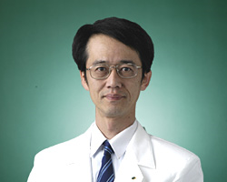

**Assistant Chief of Diabetes and Endocrinology**

Yoshitaka AKIYAMA

Department name

Diabetes & Endocrinology

Medical School

University of Tokyo, School of Medicine

Education & Career

1994: Graduated from University of Tokyo, School of Medicine

1995: The University of Tokyo Hospital

1996: Hitachi General Hospital

1997: The University of Tokyo Hospital

1998: Saitama Red Cross Hospital

1999: Kanto Medical Center NTT EC

2002: Tokyo Senbai Hospital

2005: IUHW Mita Hospital

2007: Kameda Medical Center

Subspeciality

Special Qualifications

Board Certified Physician of Japanese Society of Internal Medicine

Board Advanced Certified Specialist of Japan Diabetes Society

**Doctors in orthopedics**

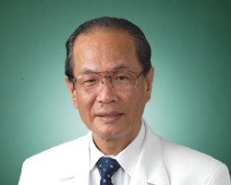

Masanori TAKAHASHI

Department name

Orthopedics

Medical School

Keio University

Education & Career

・1969: Graduated from Keio University, School of Medicine

・1976: Instractor of Orthopedics, Fujita Health University School of Medicine

・1978: Orthopedics, Saiseikai Utsunomiya Hospital

・1981: Instractor, assistant professor, professor of Orthopedics, Tokyo Dental College Ichikawa General Hospital

・2009: Orthopedics, Kameda Medical Center

Subspeciality

Hand Surgery

Special Qualifications

Rehabilitation

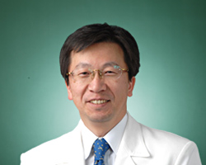

**Chief of Orthopaedics**

Hiroshi KURODA

Department name

Orthopaedics

Medical School

Tokyo Medical and Dental University, School of Medicine

Education & Career

・1986: Graduated from Tokyo Medical and Dental University, School of Medicine

・1986-1987: Residency in Orthopedicis, Hospital of Tokyo Medical and Dental University

・1987-1988: Orthopedics, Omiya Red Cross Hospital

・1988-1989: Orthopedics, Soka City Hospital

・1989-1990: Orthopedics, Toride General Hospital

・1990-1996: Orthopedics, Cancer Institute Hospital

・1996-2004: Orthopedics, Hospital of Tokyo Medical and Dental University

・2004-2007: Orthopedics, Saitama Cancer Center

・2007-2008: Orthopedics, Ariake Cancer Institute Hospital

・2008- : Orthopedics, Kameda Medical Center

Subspeciality

Orthopedic oncology

Special Qualifications

Board Certified Specialist of Japanese Orthopaedic Association

Board Advanced Certified Specialist of Japan Society of Clinical Oncology

**Doctors in cardio vascular department**

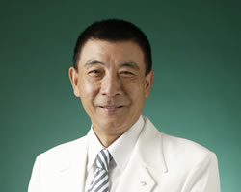

Chief of Cardiovascular Surgery

Masaaki TOYAMA

Department name

Cardiovascular Surgery

Language Spoken

English/Chinese

Medical School

Keio University School of Medicine

Education & Career

1967: Graduated from Keio Univ. School of Medicine.

1970: General and Thoracic Surgery Residency at Buffalo General Hospital. Kansas University Medical Center and Others.

1978: cardiovascular Surgeon in Miami (Baptis Hospital South Miami Hospital and Cedars Medical Center)

1983: Cardiovascular Surgeon at Kameda Medical Center.

Subspeciality

Cardiovascular Surgery

Special Qualifications

Board Certification of Japanese Society of Cardiovascular Surgery

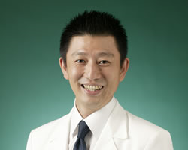

**Vice Chief of Cardiovascular Surgery**

Masanori KATO

Department name

Cardiovascular Surgery

Language Spoken

English

Medical School

Kanazawa Medical University

Education & Career

1991 Kanazawa Medical University

2002 Kameda Medical Center

Subspeciality

Adult cardiac surgery, Aortic Surgery

Special Qualifications

Board Certified Specialist, Japan Surgical Society

Japanese Board of Cardiovascular Surgery

**Doctors in general surgery**

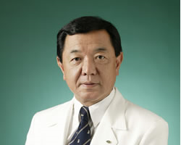

Chief of Emergency and trauma

Takeshi KASAI

Department name

Emergency and trauma department

Medical School

Tokyo Medical School

Education & Career

・1971. March: Graduated from tokyo Medical College

・1971 March - 1980 March: junior, Senior resident of Surgery at St.Lukes International Hospital in Tokyo

・1980 April: Assistant professor of Emergency department of Teikyo Medical school

・1991 Janurary: Associated professor of Emergency department of Teikyo Medical School

・2004 March: Director of Emergency department of Kameda Medical Center.

Subspeciality

Torso Trauma

Special Qualifications

Japan Surgical Association (Councilor)

Japan Surgical Association (Board)

Japanese Association for the surgery of trauma (Exective Board Member)

Japanese Association for Acute Medicine (Councilor)

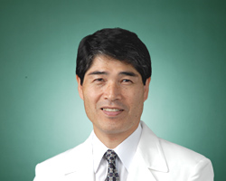

**Chief of General Surgery**

Akira TSUNODA

Department name

General Surgery

Language Spoken

English

Medical School

Showa University, School of Medicine

Education & Career

1981: Graduated from Showa University, School of Medicine

1981-1985: Postgraduate Course

1985-1986: Regidency in Surgery, Showa University Hospital

1986-1987: Assistant in Department of Surgery, Showa University Hospital

1988-1989: Honorary Assistant in St.Mark's Hospital, London

1990-1996: Assistant in Dpartment of Surgery, Showa University Hospital

1996-2001: Assistant Professor in Second Department of Surgery, Showa University Hospital

2001-2003: Chief in Department of Surgery, Yamanashi Red Cross Hospital

2003-2009: Associate Professor in Second Department of Surgery, Showa University Hospital

2009-: Chief of General Surgery, Kameda Medical Center

Subspeciality

Coloproctology

Special Qualifications

・Board Advanced Certified Specialist of Japan Surgical Society

・Board Advanced Certified Specialist of the Japanese Society of Gastroenterological Surgery

・Board Advanced Certified Specialist of the Japan Society of Coloproctology

・Board Advanced Certified Specialist of the Japan Society of Gastroenterology

・Board Advanced Certified Specialist of the Japanese Society of Medical Oncology

・Board Certified Physician of Japan Society for Surgical Infection

**Doctors in Urology**

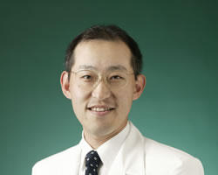

Chief of Urology

Tomonori OTA

Department name

Urology

Medical School

Tsukuba University

Education & Career

RESIDENCY IN UROLOGY; Tsukuba University School of Medicine (Ibaraki, Japan): April 1, 1986 to March 31, 1992.

Tsukuba University Hospital (Ibaraki, Japan): June 1, 1992 to March 31, 1994. August 1, 2000 to December 31, 2000.

Hitachi General Hospital (Ibaraki, Japan): April 1, 1994 to March 31, 1995.

Seinan Medical Center (Ibaraki Japan): April 1, 1995 to March 31, 1996.

RESEARCH RESIDENCY; National Cancer Center Research Institute (Tokyo, Japan): April 1, 1996 to July 31, 1997.

CLINICAL FELLOW IN UROLOGY; Tokyo Metropolitan Komagome Hospital (Tokyo, Japan): August 1, 1997 to July 31, 2000.

APPOINTMENT; Assistant Chief of Urology, Kameda Medical Center: Jan 1, 2001 to March 31, 2002.

Chief of Urology, Kameda Medical Center: June 1, 2003 to present.

Subspeciality

Urological Oncology, Urological Surgery, Endourology

Special Qualifications

Physician's License (Japan): Licensed 1992.

Graduate Medical Trainee (Tsukuba University Hospital): Certified 2001.

Board Certified Member, Japanese Urological Association: Certified 1997.

Board Certified Member, Japanese Society of Clinical Oncology: Certified 1995.

National Cancer Research Institute Residency: Certified 1998.

Ph.D. (Janan): Licensed 2000.

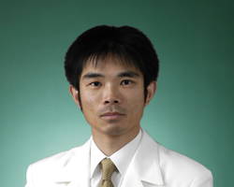

**Vice Chief of Urology**

Naoki SHIGA

Department name

Urology

Medical School

March 1993: Yamanashi Medical College

Education & Career

May 1993- March 1995: Yamanashi Medical College Hospital

September 2003-March 2005: Head of the Department of Urology, Otsuki Municipal Central Hospital

April 2005- September 2006: Assistant Chief of the Department of Urology, Kameda Medical Center

October 2006 - present: Vice Cheif of the Department of Urology, Kameda Medical Center

Subspeciality

Urology, Renal Failure and Surgical Therapy ( Access Surgery etc..)

Special Qualifications

Board Certified Member of the Japanese Urological Association

Board Certified Member of the Japanese Society for Dialysis Therapy

Fellow of the Japanese Society of Endourology and ESWL

**Doctors in gynecology**



Director of Obstetrics and Gynecology

Yukiko SHIMIZU

Department name

Obstetrics and Gynecology

Language Spoken

English

Medical School

Showa University School of Medicine

Education & Career

1982: Graduated from Showa University School of Medicine

1986: Graduated from Graduate school of Showa Univeristy School of Medicine

M.D.

Medical Specialist of Obstetrics and Gynecology

Subprofessional of Obstetrics and Gynecology, Showa University School of Medicine

1990: Postdoctoral Research Fellow in Buffalo, New York

1994: Lector of Obstetrics and Gynecology, Showa University School of Medicine

2002: Director of Obstetrics and Gynecology, Kameda Medical Center

Subspeciality

・Women's health care related to female hormone such as Menstruation problems, Menopause

・Reconstruction Operation of Pelvic Organ Prolapse(POP)

Special Qualifications

・Board Certified Specialist of Japan Society of Obstetrics and Gynecology

・Board Advanced Certified Specialist of Japan Society of Obstetrics and Gynecology

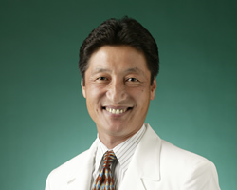

**President of Kameda Clinic**

Shougo KAMEDA

Department name

Obstetrics & Gynecology

Language Spoken

English

Medical School

Iwate Medical University, School of Medicine

Education & Career

1982: Iwate Medical University, School of Medicine

1982: Residency in OBGYN, Hospital of Showa University, School of Medicine

1983: OBGYN, Kameda Medical Center

1986: OBGYN, Hospital of Showa University, School of Medicine

1987: Clinical Fellowship at Beth-Israel Hospital, the premier Havard University Teaching Hospital in Boston

1988-1995: Vice President of Kameda Medical Center

1990: Director, Kameda Nursing Schools

1995: President of Kameda Clinic

Subspeciality

Especially, Gynecology.

Special Qualifications

1982: National MEdical License, Japan

**Doctor of Medicine**

Certified by Japan Society of Obstetrics and Gynecology

Certified by Mother's body protection law

**Doctors in oncology and hematology**

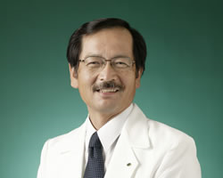

Chief of Hematology and Oncology

Kosei MATSUE

Department name

Hematology and Oncology

Language Spoken

English

Medical School

Kagoshima University Medical School

Education & Career

Subspeciality

Hematology and Oncology

Special Qualifications

Board Certified Physician of Japanese Society of Internal Medicine

Board Certified Specialist of Japanese Society of Hematology

Board Advanced Certified Specialist of Japanese Society of Hematology and Japanese Society of Clinical Oncology

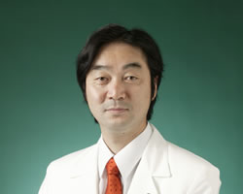

**Vice Chief of Blood Transfusion Department**

Masami TAKEUCHI

Department name

Blood Transfusion Department

Medical School

Saga Medical School Faculty of Medicine, Saga University

Education & Career

1992: Graduated from Saga Medical School Faculty of Medicine, Saga University

1992: Residency, Kameda Medical Center

1996: Hematology-Oncology, Kameda Medical Center

1998: Assistant Chief of Hematology-Oncology, Kameda Medical Center

2007: Vice Chief of Blood Transfusion Department, Kameda Medical Center

Subspeciality

Hematology and Oncology

Special Qualifications

Japanese Society of Internal Medicine

Japanese Society of Hematology

Japan Society of Clinical Hematology

**Doctors in ophthalmology**

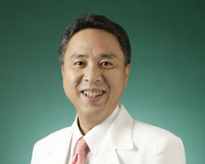

Chief of Ophthalmology

Kazuki HOTTA

Department name

Ophthalmology

Language Spoken

English

Medical School

Tottori University School of Medicine

Education & Career

1988: Graduated from Tottori University Faculty of Medicine

1988: Ophthalmology, Nippon Medical School Hospital

1993: Teaching assistant of Ophthalmology, Nippon Medical School

1996: Teaching assistant of Ophthalmology, Kyorin University School of Medicine

1996: Instructor of Ophthalmology, Nippon Medical School

1998: Ophthalmology, Duke University in USA

2000 - : Chief of Ophthalmology, Kameda Medical Center

Subspeciality

Retinal & Vitreous Surgery

Special Qualifications

Board Certified Specialist of Japanese Ophthalmological Society

Board Certified Pyshician of Ophtalmic Photo Dynamic Therapy

Doctor of Medicine

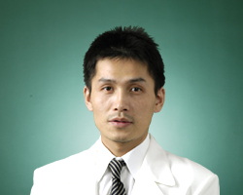

**Vice Chief of Ophthalmology**

Yasunori YOKOYAMA

Department name

Ophthalmology

Medical School

Nippon Medical School

Education & Career

1996: Graduated from Nippon Medical School

1996-1998: International Medical Center of Japan

1999-2001: Ophthalmology, Nippon Medical School Hospital

2001-2004: Ophthalmology, Nippon Medical School Chiba Hokusho Hospital

2004-2005: Ophthalmology, Hasaki Saisei Hospital

2005-2006:Ophthalmology, Kamisu Saisei Hospital

2006: Ophthalmology, Kameda Medical Center

2007-: Assistant Chief of Ophthalmology, Kameda Medical Center

Subspeciality

All ophthalmic surgery, Macula lutea degeneration

Special Qualifications

・Board Certified Specialist of Japanese Ophthalmological Society

・Board Certified Physician of Ophthalmology PDT

**Doctor in Plastic surgery**

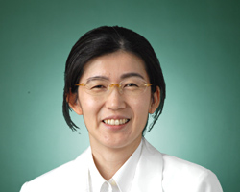

Chief of Plastic Surgery & Cosmetic Surgery

Akiko YOKOYAMA

Department name

Plastic Surgery & Cosmetic Surgery

Medical School

Tokyo Medical and Dental University

Education & Career

・1992 : Graduated from Tokyo Medical and Dental University

・1992 : Resident, Tokyo Medical and Dental University Hospital

・1993 : Dermatology, Toride Kyodo General Hospital

・1994 : Dermatology, Tsuchiura Kyodo General Hospital

・1995 : Dermatology, Plastic Surgery, Tokyo Medical and Dental University Hospital

・1997 : Plastic Surgery, Asama Hospital

・1998 July : Plastic Surgery, Hokkaido University Hospital

・1998 September : Plastic Surgery, Japanese Red Cross Kitami Hospital

・1999 : Plastic Surgery, Hokkaido University Hospital

・2000 : Plastic Surgery, Tokyo Rousai Hospital

・2001 : Plastic Surgery, Tokyo Medical and Dental University Hospital

・2007 : Plastic Surgery , Nakano General Hospital

Clinical Professor, Tokyo Medical and Dental University

・2008 : Plastic Surgery, Nakano General Hospital

・2009 : Plastic Surgery, Kameda Medical Center

Subspeciality

Plastic Surgery

Special Qualifications

Board Certified Specialist of Japan Society of Plastic and Reconstructive Surgery

**Contact us:**

**Kameda Medical Center**  
929 Higashi-cho, Kamogawa City,  
Chiba Prefecture, Japan 296-8602  
TEL:(81) 4-7092-2211